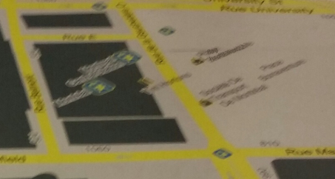

Zoom and look through the map, the flag is there. FLAG-hsdf33ksk22